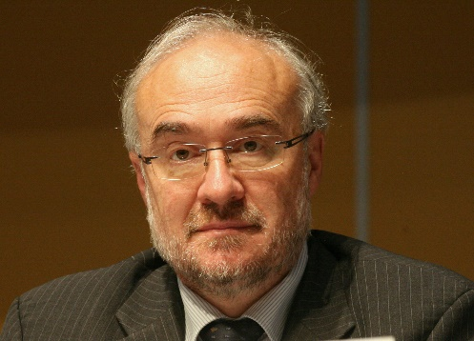
Curriculum Vitae

Michel Jarraud

Secretary General Emeritus - World Meteorological Organization

Education (University level):

1971 - 1974: Ecole Polytechnique (France) (Ecole Polytechnique is the one of the most prestigious University level scientific establishment in France
1974 - 1976: Ecole de la Météorologie Nationale (France)

Professional experience:

September 1976 – December 1985:
- Researcher in Numerical Weather Predictions (NWP) specialist of mathematical techniques for modelling the atmosphere. Played a major role in the development of the ECMWF operational numerical model, one of the leading NWP models in the world.

January 1986 – December 1989: Météo-France
- Director of French national forecasting division with responsibility for: General forecasting, including early warnings in case of extreme events

January 1990 – December 1994: European Centre for Medium Range Weather Forecasts (ECMWF)
- Deputy Director of ECMWF (from 1.1.1991) and Head of Operations Department

January 1995 – December 2015: WMO (World Meteorological Organisation)
- Deputy Secretary General (1995-2003)
- Secretary General (2004-2015)
Member of the CEB (Chief Executives Board of the UN system, chaired by the UN Secretary General) (2004-2015)

January 2012 – January2016:
- Chair UN-Water, the coordination body for all water related issues in the UN System

January 2016 – now
- Member of several scientific advisory committees
- Special Advisor on climate issues for the African Union ARC initiative 2018-now
- Invited Professor at Graduate Institute of International and Development Studies: 2020-2021

Distinctions:
- Secretary General Emeritus WMO (from 2016)
- Doctor of Science (Honoris Causa) of the Universidad Nacional Agraria
« La Molina », Peru (April 2004)
- Honorary Professor of the Nanjing University of Information Science & Technology, Nanjing, China (May 2010)
- Honorary Doctor of the Yerevan State University of Architecture and Construction, Armenia (October 2013)
- Silver medal (highest distinction) of the EMS (European Meteorological Society for contribution to the development of European meteorology (September 2016)

